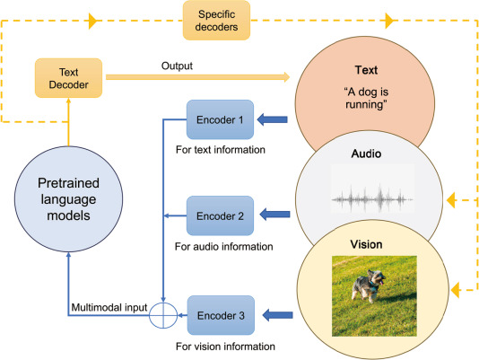
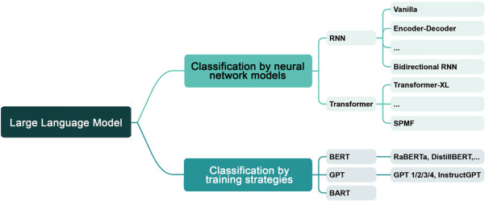

Large language models for human–robot interaction: A review - ScienceDirect
aclanthology.org/W02-0216.pdf Multi-tasking and collaboration Activites in Dialogue systems.
It can be used when people give multiple tasks to rebots to do.

(PDF) Hybrid Chat and Task Dialogue for More Engaging HRI Using Reinforcement Learning*
https://researchportal.hw.ac.uk/en/publications/a-multi-party-conversational-social-robot-using-llms/
https://researchportal.hw.ac.uk/en/persons/oliver-lemon/

